Dakota Territory Challenge Aug 29th - Sept 2nd, 2024
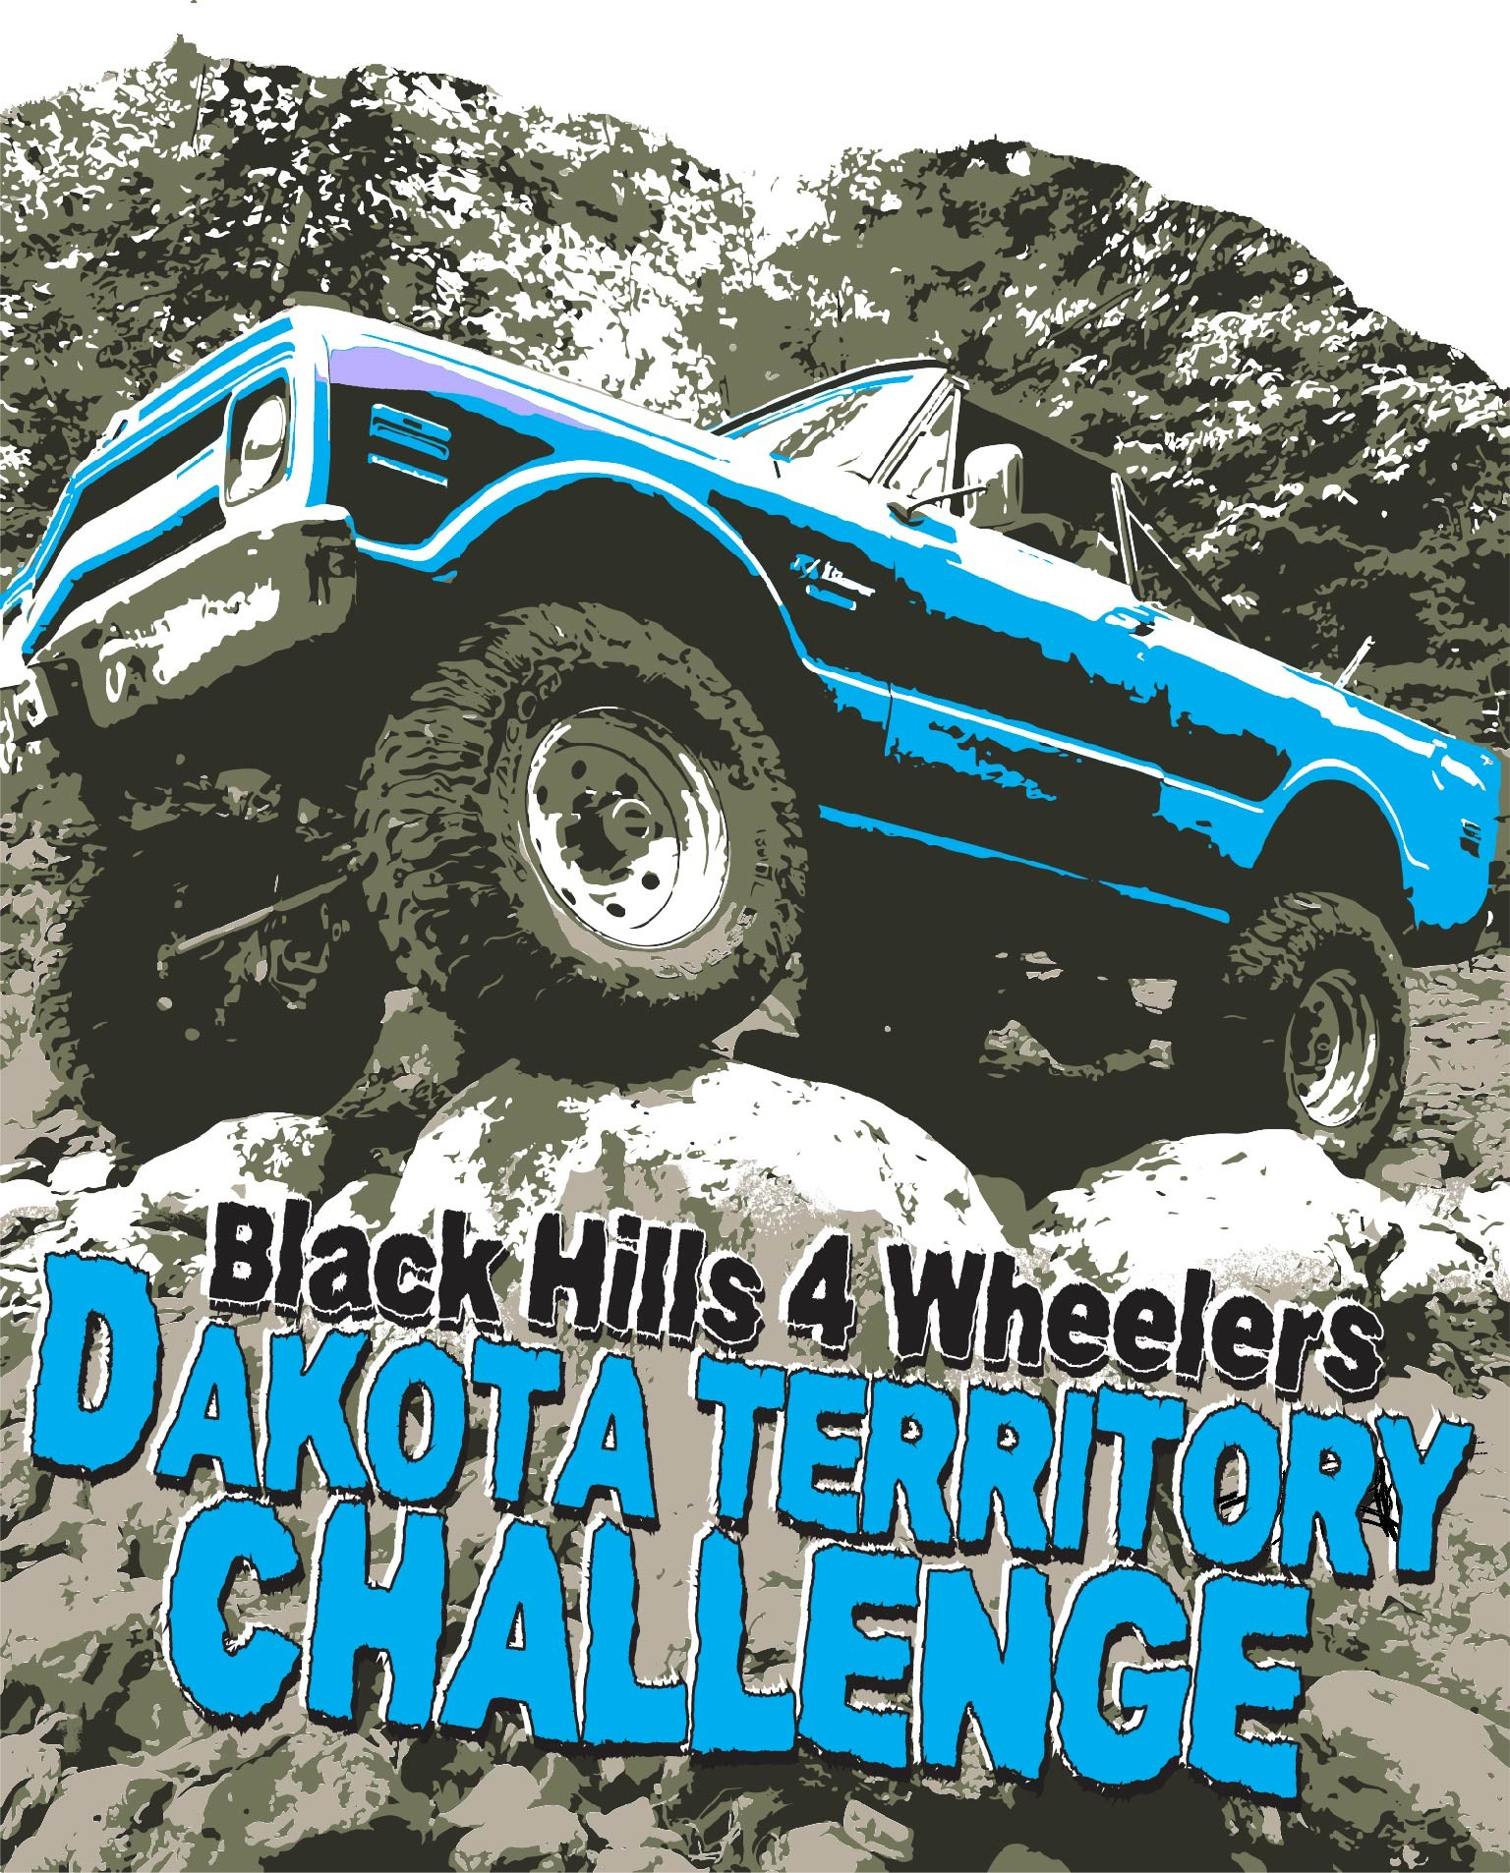
The Black Hills 4 Wheelers is once again hosting the 42nd Annual Dakota Territory Challenge! This is a fun-filled family trail ride event offered over 3 days. We have trails for ALL LEVELS. Scenic, Mild, Medium, and Hard technical rock crawling trails are all available each day of the event. Club members are available on every trail to guide, spot, and assist each participant as needed. Trails are assigned ratings that outline the vehicle requirements along with posted trail descriptions. Please review the vehicle requirements and come prepared!

DTC will be held at Hidden Valley Campground located just South of Deadwood, SD. A more convenient location and change for something closer to the trails. The campground is a little bit more cozy but we get to have campfires! When planning your trip be aware parts of Highway 385 are under construction.
Dogs are allowed at the campground; following the campground rules. It is important to note that all pets need to be on a leash in the campground at all times (campground rules) and cannot be left alone to bark in the campground! Dogs (all pets) are NOT allowed to ride along on the trails for safety measures.
There are two kennels in the area: Deadwood Doghouse 605-641-0857 and The Paw Spa 605-559-3009.

Registration deadline is July 15st, 2024 and limited to the first 55 paid vehicles!

T-shirts and sweatshirts with the Challenge theme (see above logo) will be offered online or with this application. (See below for more details and pricing)
Please review the Event Rules, Registration details, Trail Ratings, US Forest Service Permit Requirements, Campground rules and Schedule of Events (subject to change before the event) before registering!
Should you need more information or help with a specific situation, please email or call.

Karen Eads 605-484-9764
bh4wheelers@gmail.com
Tammy Field
605-863-2512
bh4wheelers@gmail.com

Permit Requirements
A Forest Service permit is required for each OHV using trails in the Black Hills National Forest. Permits can be purchased at a location listed below and online: http://www.fs.usda.gov/main/blackhills/passes-permits

Mystic Ranger District, 8221 S. Hwy 16, Rapid City, SD 57702 605-343-1567
Northern Hills Ranger District, 2014 N. Main Street, Spearfish, SD 57783 605-642-4622 Supervisor’s Office, 1019 N. Fifth Street, Custer, SD 57730 605-673-9200 Black Hills Visitor Information Center, 1851 Discovery Cir, Rapid City, SD 605-355-3600 Pactola Visitor Center, Southside of the Dam on Hwy 385 605-345-8755

Or at the Steel Wheel Trading Post located next door to Hidden Valley Campground!
It is your responsibility to have your permit for the event.

Trail Ratings
The rating system is based on a 1-10 scale with 10 being the hardest. Traction devices are considered limited slips or devices that require a certain wheel speed to engage. A locker does not require wheel spin to engage.
Difficulty 5: At this rating you are starting to stretch the capabilities of a stock vehicle and the novice driver.
Body damage possible. Low range, high clearance, and 4 wheel drive required.

Difficulty 6: Larger than stock tires; 1 locker or 2 traction devices required; Winches advised due to large boulders, steep inclines, etc. Body damage likely.

Difficulty 8: Not advisable for novice drivers; potentially dangerous situations; maximum ground clearance;
lowest gears; Body damage likely. 35”+ tires, 2 lockers, and winch are required.
Difficulty 10: Purpose built buggy style vehicles, 39”+ tires, 2 lockers, and winch are required. Body damage likely.

A vehicle with a lower trail rating may be allowed on a trail at the trail leader's discretion.

VEHICLE REQUIREMENTS – Checked at technical inspection
- Accessible Fire Extinguisher
- Roll Bar on Soft-Tops
- Spare Tire – Can be left at the trailhead on a trailer
- First aid kit
- Seat Belts for all occupants
- Full exhaust system, no open headers
- Recovery Points (Front and Rear)
- Registration, Insurance, and OHV Permit
  - Vehicles trailered to the trailhead must have insurance and permit.

Event Rules
- No Alcohol/Illegal Substances allowed on the trail. This includes any time you are participating in an event trail ride, being a spectator of an event trail ride, or driver's meeting. Failure to respect this rule will result in being asked to leave the event and reported to the proper authorities.
- NO PETS allowed on Challenge trail rides. This includes dogs.
There are two kennels in the area: Deadwood Doghouse 605-641-0857 and The Paw Spa 605-559-3009.
- VHF radios will be used by the trail leaders for trail communication. We encourage participants to purchase one of these radios for the event. The BaoFeng UV-5R+ programmed radio will be available for purchase at the event. (Approx $50)
- Drive responsibly to protect the environment and only where motorized vehicles are permitted. The trail leader is responsible for the conduct of the trail ride and his/her decisions are final. If you leave a trail ride before the conclusion, you must contact the trail leader before leaving. We STAY THE TRAIL and TREAD LIGHTLY! on all trails.
- All participants must abide by U.S. Forest Service rules and regulations. Do not take items from historic sites; leave
history for all to enjoy.
- Always maintain visual contact with the vehicles behind you. Stop and wait for the vehicle behind you if you lose sight.
- Vehicle technical inspections will be conducted for required safety and trail equipment.
- All vehicles must be registered four-wheel drives and must have proof of liability insurance. The BH4W’s are not responsible for accidents, damage, or injury to persons or vehicles. All drivers must be at least 18 years old and are responsible for the occupants of that vehicle. All occupants must be registered, paid for, and sign a waiver. No motorcycles, three wheelers, ATV's, SXS, etc., will be allowed at any time.

- Forest Service OHV Permit is required.
- Refrain from smoking on the trails, only allowed in an enclosed vehicle.
- All trail repairs requiring cutting, grinding or welding will only be allowed at the discretion of the trail leader and under his/her direct supervision due to fire dangers.

- Failure to follow DTC rules will result in being asked to leave the event without a refund.

- Pet friendly campground:

Campground Rules

  - Pets must always be on a leash. If you are not at the site they must be kept inside.
  - YOU MUST CLEAN UP AFTER YOUR PET(s).
  - IF they become a nuisance, you will be asked to leave or take them to a kennel.
- Fire Rings cannot be moved.
  - Trash remaining in fire rings at the end of the event is subject to A $20 clean-up fee

- Speed Limit is 5 mph

Registration

The registration & camping fee for one vehicle and driver is $300.00. Each additional passenger 16 and up is $30.
Children under 16 are free.
Cabins $450.00. Contact Karen Eads for cabin availability.

Registration fees postmarked after July 15th will be $350 for each vehicle and driver.
The application is only available to download @ www.bh4wheelers.com. Return pages 7 and 8 along with a check in US funds or PayPal; include email address for online payment. (You will then be contacted via PayPal with a request for payment.) Please make sure you sign the application before mailing it. Retain the rest of this application for reference.
Mail application to the following address:
Black Hills 4 Wheelers PO Box 1354
Rapid City, SD 57709-1354

Or email completed form to: bh4wheelers@gmail.com
Group attendees may put all registrations together in the same envelope. Large Groups (8+) may not be able to trail ride together every day. Large groups may not be guaranteed adjacent camping spots.

Cancellations prior to August 15th, 2024 will be refunded after the event. Notifications for registration transfers must be received by August 15th, 2024. Returned checks are charged $35 NSF fee.
An email or text will be sent verifying your registration was received and accepted.

Please fill out your application and sign at the bottom of the application.
All participants must sign the waiver, including children and legal guardian of all minors. See page 8 for details.

Campground
Hidden Valley Campground is our headquarters this year! Located at 21423 US Hwy 385, Deadwood, SD 57732
Full hookups are not guaranteed. Site assignments will be based on best fit and availability of spaces. Size of spaces and hookups (full and electric only) are limited. There is plenty of space for tents or dry camping; generators are allowed.

Schedule of Events

*The Dinner Bell is a cast iron bell that is rung to gather everyone together.

THURSDAY, August 29th
8:00 am - 5:00 pm Check-in/technical inspection 5:00 pm - 7:00 pm Social hour, Seibert/Stulc BBQ!

Dinner Bell (≈7:30 pm) 8:00 pm
Challenge Welcome and Driver’s Briefing
Trail ride sign-up

8:30 pm Night run?
FRIDAY, August 30th

8:00 am  7:30 am - | 8:00 am | Last minute trail ride sign up  Late check-in and technical inspection
8:30 am - | 9:30 am | Trail rides depart camp
4:00 pm - | onwards | Trail rides return to camp
7:00 pm - | 7:30 pm | Merchandise Open
Dinner Bell  8:00 pm  9:00 pm – | (≈7:30 pm)  onwards | Door Prizes give-away (must be present to win)  Trail ride sign-up  Social Hour or fix your broken rig and/or ego!

SATURDAY, August 31st

8:00 am |  | Last minute trail ride sign up
8:30 am - | 9:30 am | Trail rides depart camp
4:00 pm - | onwards | Trail rides return to camp
Dinner Bell | (≈6:00 pm) | DTC Dinner – Pizza Boy will be catering!
8:00 pm |  | Trail ride sign-up
8:30 pm - | onwards | Social Hour or more fixing

SUNDAY, September 1st

8:00 am |  | Last minute trail ride sign up
8:30 am- | 9:30 am | Trail rides depart camp
4:00 pm - | onwards | Trail rides return to camp
7:00 pm - | 9:00 pm | Merchandise Open
Dinner Bell (≈7:30 pm) Special Awards

MONDAY, September 2nd
Any Time Pack up, head home, and plan for next year’s Challenge

Color variations may occur due to stock on hand.
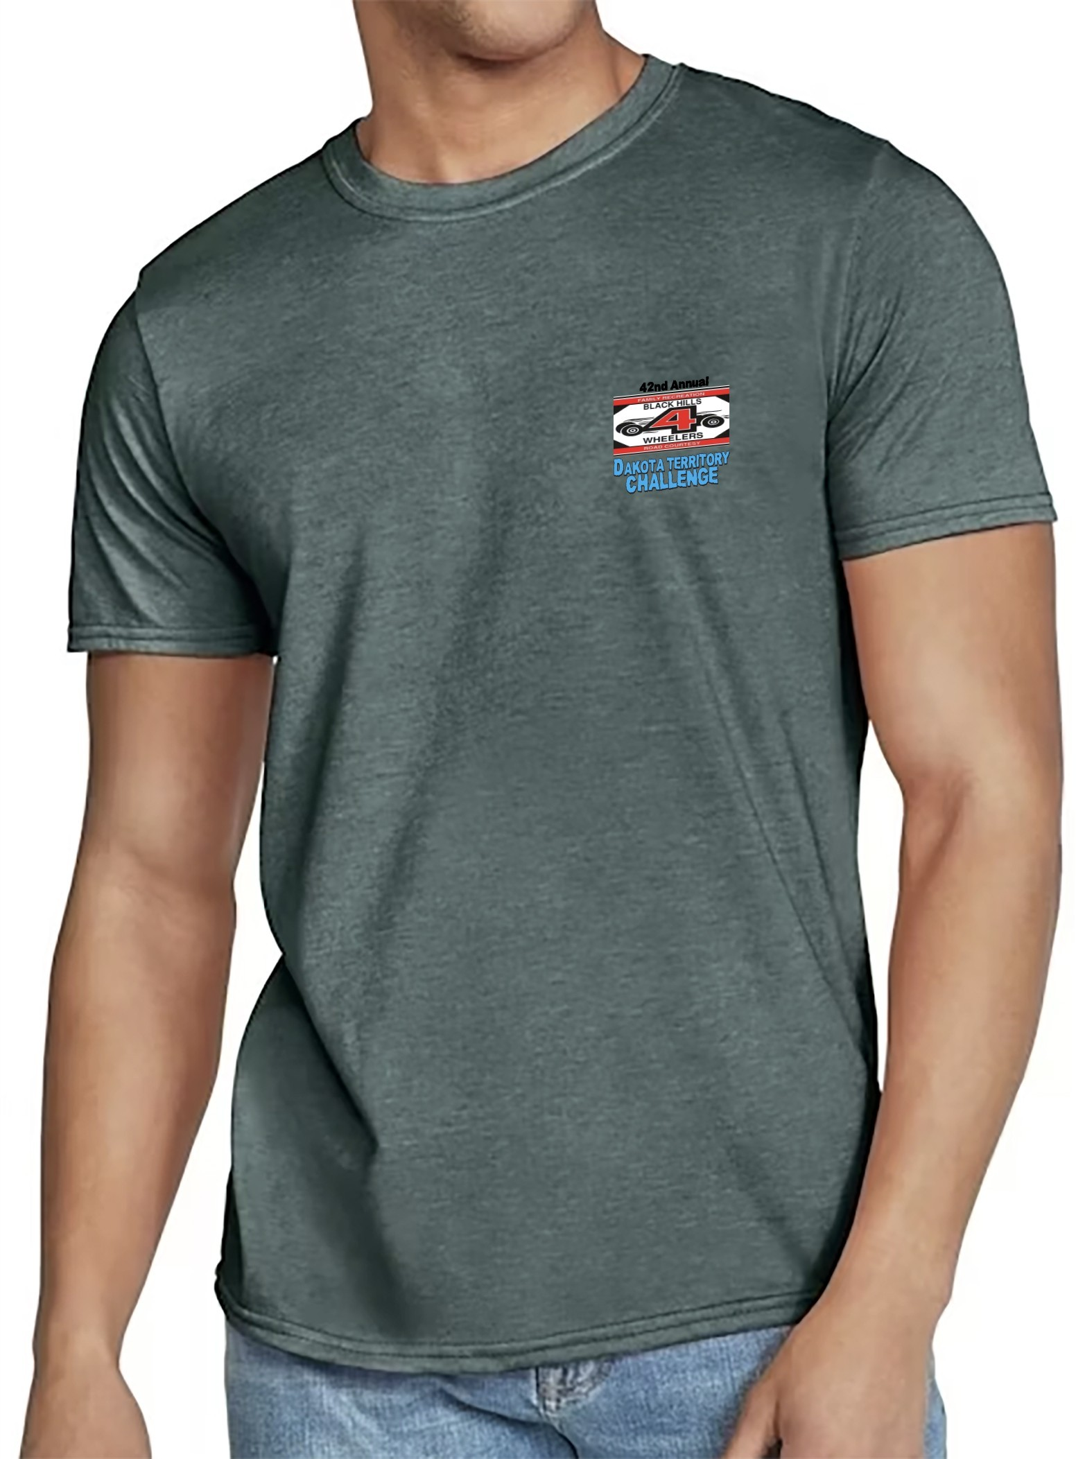

2024 DAKOTA TERRITORY CHALLENGE APPLICATION
Last Name: |  |  | First:
Address:
City: |  | State: |  |  | Zip: |  | Country:
Vehicle Type: |  | Year: |  |  | Plate:
Cell Phone #: |  |  |  | Emergency Contact:
Email Address: |  |  |  | Emergency Contact #:
Please include your camping setup. Full hookup are not guaranteed. Space will be assigned based on best fit and availability at event.
Limited Hookups
Tenting
RV Length Camper Length
All vehicle trailers will be parked in the back field, not the campsites.
Last Name First Name

Registered driver and 1 vehicle:
Passengers 16
and older
$30 each
Passengers
under 16 Free
$300
(includes camping)

I hereby have read and understand all Rules and Regulation’s posted in this application.
Signature:
Date:

2024 DAKOTA TERRITORY MERCHANDISE ORDER (Double Click in Excel Table)

7/8

2024 DAKOTA TERRITORY CHALLENGE

RELEASE AND WAIVER OF LIABILITY AND INDEMNITY AGREEMENT

In consideration of being permitted to officiate, work for, or for any purpose whatever to participate in the Dakota Territory Challenge, the undersigned for himself/herself, his/her personal representatives, heirs, and next of kin; HEREBY RELEASES the Black Hills 4- Wheelers, the Dakota Territory Challenge Committee; the United States Forest Service; Badlands National Park, officials; and crew members; all referred to herein as Releasees, from any and all liability to the undersigned, his/her personal representatives, heirs, and next of kin for any loss or damage on account of injury to the undersigned or his/her property or resulting in the death of the undersigned whether caused by the negligent act or omission of Releasees while the undersigned is officiating, working, or for any purpose participating in such event.

IN ADDITION, the undersigned AGREES TO INDEMNIFY AND HOLD HARMLESS the Releasees from any loss, liability damage or cost they incur due to any such officiating, working, or participating by the undersigned, whether caused by Releasees negligence or otherwise AGREE TO ASSUME FULL RESPONSIBILITY AND RISK for any bodily injury, death, or property damage from Releasees negligence or otherwise while the undersigned is officiating in, working for, or for any purpose participating in the Dakota Territory Challenge.
All participants will need to sign below.

A minor shall write the word “MINOR” and his/her age next to his/her name. A minor shall also
have parents, the parent with legal custody, or his /her legal guardians sign this release form. DATE PARTICIPANT’S SIGNATURE* PRINTED NAME
DRIVER/OWNER PASSENGER PASSENGER PASSENGER PASSENGER

8/8

